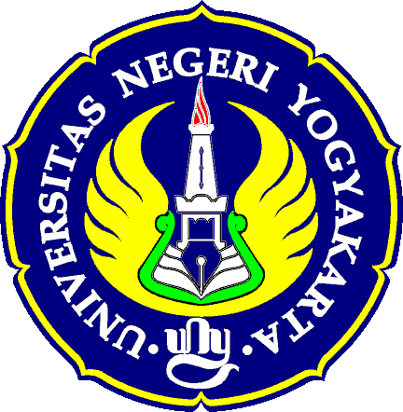

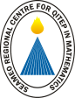

PARTICIPANT’S FORM

2nd Evaluation Meeting: Pre-Service Student Teacher Exchange in Southeast Asia
(SEA-Teacher Project)

UNY Hotel, Ballroom
Yogyakarta, Indonesia

Please fill out this form and return to the SEAMEO Secretariat by 23 September 2016
Via email: napa@seameo.org

PARTICIPANT’S PROFILE
Title: |  | First Name: |  | Middle Name: |  |  |  |  |  | Last Name:
Position:
Office Division/Unit:
Organization:
Address:
City: |  |  | Postcode: |  |  |  |  |  | Country
Tel: |  |  |  |  |  | Fax:
Email:
MEETING’S SESSION (Please indicate the meeting you will attend)
2nd batch evaluation meeting and collaboration of 3rd batch
Networking Session (for university who wish to extend the exchange period to be more than 1 month and universities who have training for TVET teacher)

TRANSPORTATION
Yogyakarta State University (UNY) will provide only transportation from hotels to the meeting venue.
Participants are requested to arrange their own transportation from airport-hotel-airport. Note: information of Taxi is provided in the attached document.

ACCOMMODATION
All participants are requested to make reservation directly to the hotel no later than 30 September 2016 (attached is the details info. of the hotels)

*Please tick [ ✓] hotel below
No | Hotel Address |  |  |  | Room Rate  (Rupiahs) |  |  | Time allocation to reach UNY
[ ] 1. | UNY Hotel  Jl Colombo, Kampus  Universitas Negeri  Yogyakarta  Tel: (0274) 553078  http://unyhotel.esy.es |  |  |  | 400,000-1,500,000 (approximately) |  |  | 2 minutes (7,500 m) via Jl Colombo  3 minutes (8,500 m) via Jl guru Mulia 1 and Jl Colombo  4 minutes (7,500 m) via Jl UNY Boulevard
[ ] 2. | Jogja Plaza Hotel  Jl H affandi  Gejayan, Komplex Colombo  Daerah Istimewa Yogyakarta  Tel: (0274) 584222  http://www.jogja.pphotels.com |  |  |  | 600,000-1,000,000 (approximately) |  |  | 1 minute (2,600) via Jl Affandi dan Jl, Colombo
[ ] 3. | Ambarrukmo Hotel  Jl Laksda Adisucipto  No 81, Caturtunggal, Kec Depok  Kabupaten sleman  Daerah Istimewa  Yogyakarta 55281  Tel: (0274) 488488  http://www.royalambarrukmo.com |  |  |  | 1,000,000-4,200,000 (approximately) |  |  | 10 minutes (3.3 km) via Jl Laksda Adisucipto
Cultural Visit on 9 Oct 2016 (special price package tour provided by Yogyakarta State University)
The participants do not need to pay transportation fee. The transportation will be provided by Yogyakarta State University. The price includes ticket fee and lunch box. (please see details in the attached document)

*Please tick [ ✓] your preference below (just one choice only)
Kraton-Borobudur-Ullen Sentalu (Rupiahs 430,000)
Kraton-Prambanan-Ratu Boko (Rupiahs 450,000)

CONTACT PERSONS
Ms Retna Hidayah  Deputy Director  Office of international Affairs & Partnerships  Yogyakarta State University  Tel: +62 813 28268438  E-mail: retnadewa@yahoo.com  Ysu.internationalaffairrs@gmail.com |  |  |  |  |  |  | Ms Kanokwan Arreenich  Documentationh and Resources Officer  SEAMEO Secretariat  Mom Luang Pin Malakul Centenary Building  920 Sukhumvit Road  Bangkok 10110, Thailand  Tel: +66 (0) 2391 0144  Fax: +66 (0) 2381 2587  E-mail: kanokwan@seameo.org

