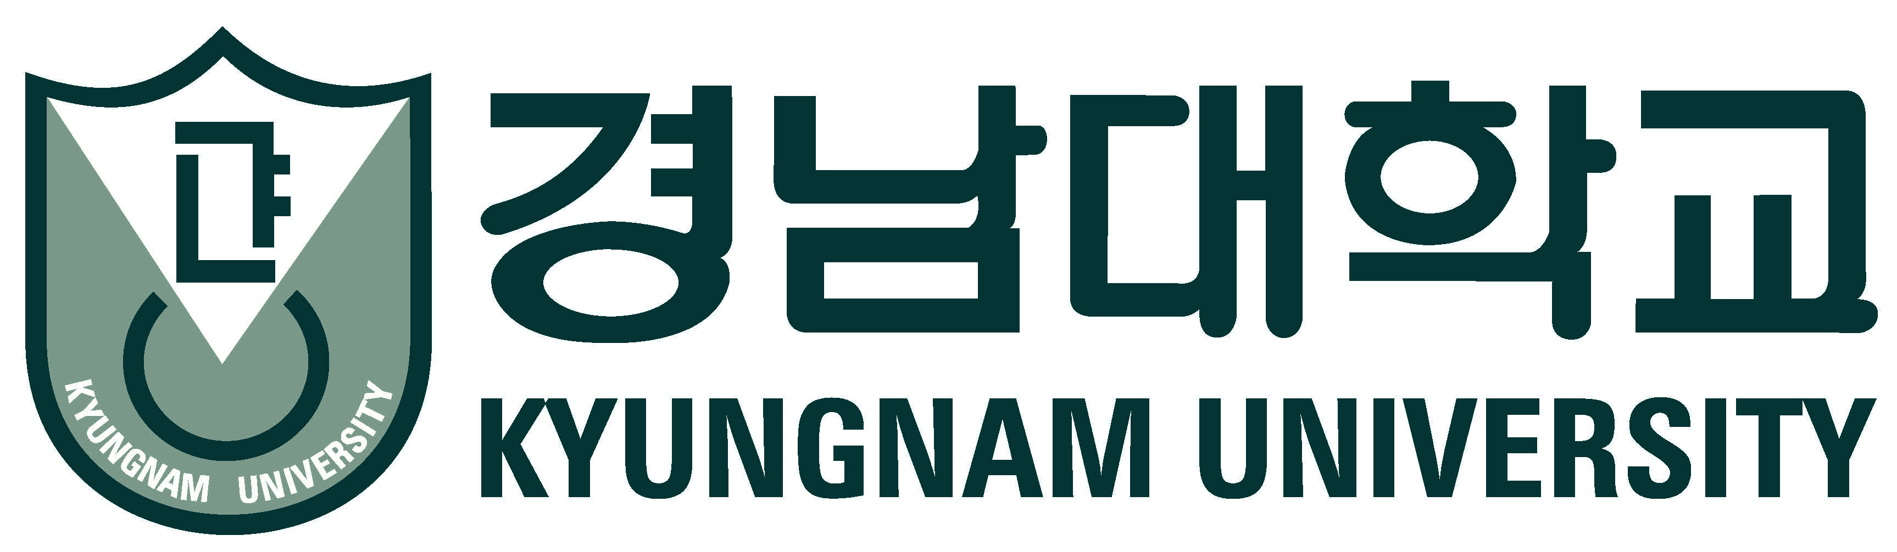
2015 ODA Full Scholarship for International Students Information
ODA(Official Development Assistance) Full Scholarship is supported by the Korean government, and is intended for students from developing countries who would not otherwise be able to afford to undertake Bachelor level study in Korea, to gain skills and knowledge which will allow them to contribute the development of their home countries. Once they enter Kyungnam University, they are not allowed to withdraw or transfer to other universities.
- Name of Scheme: Kyungnam University ODA Full Scholarship Scheme
- Number of students for selection: Total 6 students(from all countries)
- Number of Nominees: 2 students from each Institution
- Applicant Eligibility
-Both parents must be international nationals. The applicant will graduate or has graduated from a school abroad.
-Applicants must have Level 3 or over in TOPIK(Test of Proficient In Korean), 70 in TOEFL, or 5.5 in IELTS.
-Applicants must have a grade point average of 80% or higher on their high school transcript.

- Application Dates
-Application Form Submission in person or by post: June 26, 2015
-Interview(Off-line or On-line) June 29, 2015
-Announcement of Acceptance July 2, 2015

- Scholarship(4 year)
-Waiver of tuition fee
-Waiver of dormitory fee
-Support equal to $1,000 USD for flight fee subsidy (once)
-Support equal to $500 USD for monthly allowance (every month)
-Support equal to$150 USD for medical insurance fees (every year)
※Each semester students should obtain an average grade of 2.5 and above to be eligible for the scholarship.

- Required Application Material
- KU application form(www.kyungnam.ac.kr/global)
- Official high school transcript and diploma
- Recommendation Letter from principal of high school
- Language Proficiency Test Scores
- Applicant’s or sponsor’s bank statement
- Family Census Certificate
- Copy of Passport

- Contact information
-Minjoun Shim, International Exchange Coordinator, Kyungnam University,
7 Kyungnamdaehak-ro, Masanhappo-gu, Changwon-si, Gyeongsangnam-do, 631-701 Korea
-Tel : +82-55-249-2969
-Fax :+82-55-247-9344
-e-mail: shimlondon@kyungnam.ac.kr
-web page: www.kyungnam.ac.kr

※For the general or more detailed information on related to Kyungnam University admissions, please refer to the attached “International Students Course and Fee Information”

