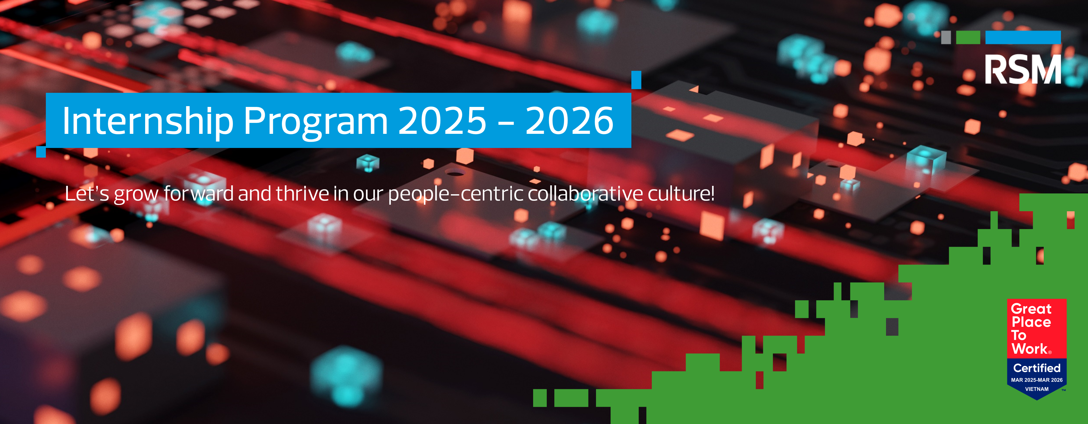

RSM Vietnam Internship Program 2025 - 2026
Let’s grow forward and thrive in our people-centric collaborative culture!
Undergraduate Program for Our Candidates:
- Final year students or recent graduates with Auditing, Accounting, Finance, Public Finance, Business, Banking or Economic background.
- Demonstrate strong communication and interpersonal skills.
- Able to pursue the passion of continuous learning and development.

Application: If your background meets these requirements, please submit an English or Vietnamese detailed resume, transcript, and other qualifications (English qualifications, ACCA, etc.) to our Talent Acquisition Team: careers@rsm.com.vn
Or complete the Forms above.
What You’ll gain at RSM Vietnam – A Great Place to Work™
- Real exposure to professional careers
- Hands-on experience and on the job training opportunities
- Mentorship & Collaborative culture
- Official Internship Certificate
- Career advancement opportunities after Internship

Let’s kick start your career at RSM by joining:
- Audit & Assurance Services: https://bitly.li/efL3
- Tax & Consulting Services:
- Transfer Pricing Services: https://bitly.li/VSFM
- Accounting & Corporate Tax Services: https://bitly.li/rFR0
- Transaction Advisory Services: https://bitly.li/6Km0

Special Qualification Exemptions: Having ACCA certificates with evidence attached to the application will be exempted from:
- CV Screening: Passed 2 out 3 F1/ F2/ F3 or above.
- Testing:
  - Audit & Assurance Services: Passed 3 papers of F3, F7, F8.
  - Tax & Consulting Services: Passed 3 papers of F4, F6, F7.
- Final Interview: No exemption

Please kindly notice that only short-listed candidates will be contacted!

